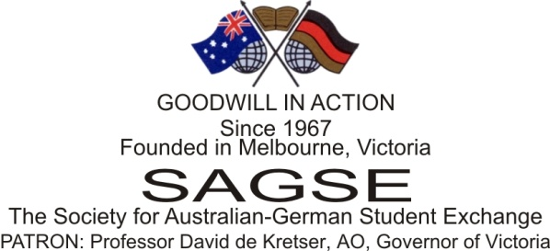
Patron: Mr Torsten Ketelsen, Honorary Consul of the Federal Republic of Germany in WA

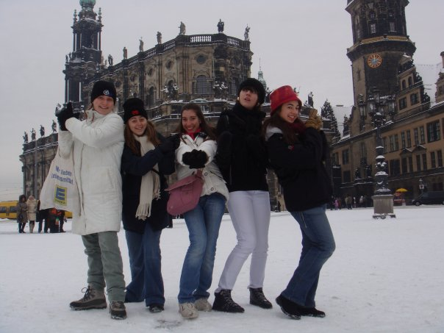
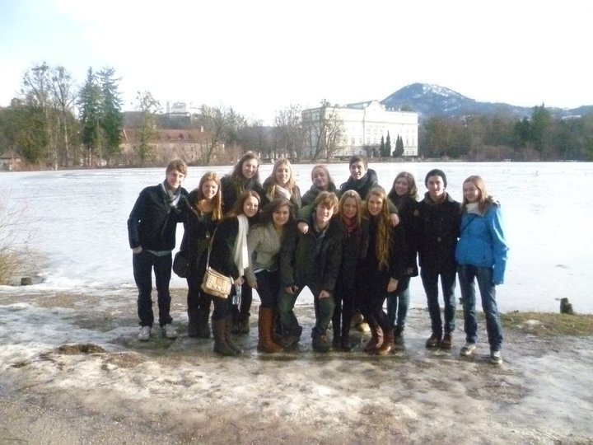
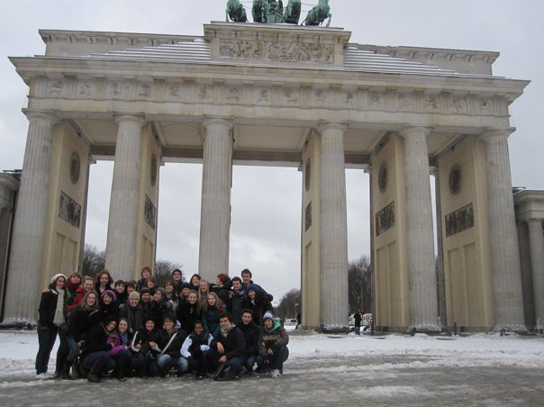
SAGSE WA | Scholarship Guide 2016

OPPORTUNITY OF A LIFETIME!!!

Travelling to Germany is a once in a lifetime opportunity. It is a trip that you will remember forever, leaving you with incredible memories and a network of new friends around the globe. The Society for German Australian Student Exchange (WA) Onc. is a unique not-for-profit society dedicated to sending Western Australian students overseas for a life changing experience.

This Scholarship Guide is intended to answer any questions you may have about the scholarship. Of course, there will be other opportunities for you to ask any questions you have at the scholarship interviews.

If after reading this guide you would like to apply for a scholarship, pick up an application form from your German teacher.

Applications for 2016 close on Friday 6 November 2015.

We look forward to receiving your application soon!

Liebe Grüsse

The SAGSE WA Team

What is the Society for Australian German Student Exchange?

The Society for Australian German Exchange (SAGSE) was founded in 1967 by Mr Fritz von Einem-Joosten, a German businessman who wanted to foster international understanding by means of a German-Australian youth exchange. He sought sponsorship from a number of German firms operating in Australia. Since then, the Society has been able to give a select group of students of German in secondary schools the opportunity to improve their knowledge of the language and to get to know German people by living in the country for a period of time. Now, over forty years on, the work of the Society continues thanks to the generous support of many Australian and German businesses. The Society now has branches in Victoria, New South Wales and Western Australia with affiliated programs in Queensland and New Zealand.

What is a SAGSE Scholarship?

The scholarship program allows selected students to travel to Germany and participate in an extended cultural exchange from late November to early February. During their time in Germany, students will live with a host family, experiencing day to day life with a German family. They will attend school with their host brother/sister, and also participate in a wide range of cultural and social activities. These include a winter camp, a week long trip to Berlin, and a number of ‘regional days’ in cultural capitals throughout Germany. Scholarship winners also get the opportunity to attend functions with Australian and German embassy officials.

What does the scholarship cost?

A SAGSE Scholarship is unique in that it is considerably cheaper than any other program offered to students in Western Australia. The scholarship covers airfares, accommodation with a host family and many social activities and camps when in Germany. However, there are additional costs that must be met by the student’s family, mainly travel insurance and pocket money. The Society would suggest, as a rough guide, that around $1000-$1500 would be sufficient to ensure the student gets the most out of the exchange program.

Who can apply for a Scholarship?

Scholarships are available to students who meet the following basic criteria:

- Australian citizen
- Currently enrolled in Year 10 or Year 11
- Studying German and will be studying German in upper school
- Planning to continue studies of German at tertiary level

Candidates should also possess the following essential qualities:

- Strong academic achievement
- A wider contribution to the school community and participation in extra-curricular activities
- Excellent communication skills
- An interest in and understanding of both German and Australian history and culture
- Ability to adapt to new environments easily
- Ability to speak some basic everyday German

How will scholarship winners be selected?

Candidates will be assessed based on their written application and a short interview with a selection panel.

The interviews are relatively informal and are a good opportunity for you to ask any questions you have about the scholarship. You will be asked some questions about the selection criteria outlined above, so be sure to refer to that when preparing for your interview. You may be asked a few questions in German, for example to describe yourself, hobbies, etc. However, the majority of the interview will be conducted in English. The interviews are usually held at the end of November and candidates will be advised of the time and date closer to the date.

What happens if I am selected as a scholarship winner?

Congratulations! You will be travelling to Germany from November 2016 to early February 2017, so keep the dates free! You are required to fly to and from Germany with the entire scholarship group on the dates selected by SAGSE. Should you be unable to do this, your scholarship will be revoked.

You will be contacted by a representative of SAGSE WA to confirm you have been awarded a scholarship and they will keep in touch with you over the next year before you leave.

You will be asked to host a German student mid-year 2016. This is a requirement for receiving a scholarship. You will be asked at your interview if you can host a German student, so be sure to discuss this with your parents beforehand and they will need to sign to acknowledge this. Hosting a German student is a very rewarding experience for both you and your family. Representatives from SAGSE WA can brief you and your family on hosting at a later stage and offer support and events whilst the German students are in Perth.

Your German student will attend school with you so please confirm that your school will accept a German student for appproximately10 weeks.

In November 2016 you will be invited to attend a Scholarship Presentation Function where you will be officially presented with your scholarship, shortly before heading off to Germany for the trip of a lifetime.

Over the year before you leave you will also be invited to attend events run by the German Australian Students’ Society (GASS WA). GASS WA is the society for returned scholarship winners. They will be able to tell you exciting stories about their trips to Germany, and help you with any questions that you may have.
As a scholarship winner you will also be expected to attend GASS meetings and events after your exchange. In particular you will be asked to mentor the 2017 awardees in preparation for their trip.

What happens when I return from Germany?

After your trip you will be welcomed back to Perth at a GASS WA function. You will then be welcomed into the society as a ‘GASSie’ and can continue to join in the many exciting events held by GASS WA each year to keep sharing your experience for years to come.
You will also be asked to write a short report for the sponsors about your trip.

Sounds great! So how do I apply?

If you like what you hear, you can get an application form from your German teacher. Follow the instructions on the application form and make sure you submit it by the deadline of 5pm Friday 6 November 2015.
To whet your appetite, below are some comments made by past students who have participated in the exchange.
We look forward to receiving your application soon!

“There are not many words to describe my ten week exchange in Germany – it exceeded all expectations. I was blessed with an amazing host family and was stunned by the beautiful German town of Lübeck. Overall, Germany was an amazing, eye opening experience.” – Liz Parsons, 2009 Scholarship Winner

“My ten weeks in Germany was one of the greatest experiences of my life. It was an opportunity to learn independence as well as forming bonds with families across the globe. Overall the experience has taught me that although life may bless us with many opportunities, we only get the most out of those we invest in.” – Anthea McCormick, 2005 Scholarship Winner

“The three months that I spent in Germany were unique and life changing. My time in this beautiful country allowed for a number of valuable and amazing experiences that have shaped me in so many ways. I have made strong connections with wonderful people. Submerging myself in the German culture has vastly improved my use of the language and my knowledge of the country, as well as increased my confidence and thirst for travel and the subsequent broadening of my horizons.” – Shannai Belton, 2014 Scholarship Winner

